Background information on the Area for Intervention: HIV self-testing

Adapted from content developed for the unitaid 26th executive board meeting held in December 2016

Content

1.1. Why now and what are the key issues? 3
1.1.1. Those left-behind by conventional testing approaches 3
1.1.2. The potential of HIVST 4
1.1.3. The evidence supporting HIVST 4
1.1.4. Country appetite for HIVST 5
1.1.5. HIVST product landscape 5
1.1.6. Shortcomings of HIVST market in LMICs 7
1.2. Possible interventions in the next 24months 7
1.2.1. Early-adopter countries 7
1.2.2. Cost of Inaction and potential impact 8

Background information for Area for Intervention:
Expanding access to HIV self-testing in LMICs

This document has been adapted from a background document submitted to UNITAID’s Executive Board in December 2016, providing a high-level preliminary understanding of the key challenges seen at the time related to HIV self-testing scale-up. UNITAID’s Executive Board endorsed the proposed Area for Intervention, thus enabling the UNITAID Secretariat to launch calls for proposals in this area.

This document aims to provide the preliminary background and rationale for UNITAID’s call in this area. However, UNITAID recognizes that there may be additional market-related challenges and approaches beyond those noted in this document. UNITAID welcomes any proposal that makes a strong case for meeting the objectives of this area for intervention.

Why now and what are the key issues?

Those left-behind by conventional testing approaches
Access to HIV testing services in LMICs has experienced dramatic growth over the last two decades, to the extent that more than 600 million people in 122 LMICs reported receiving an HIV test between 2010 and 2014. In Sub-Saharan Africa, the region most burdened with HIV infection, there has been a five-fold increase in HIV testing awareness for PLHIV over a span of ten years.

Despite these achievements, over 40% of all PLHIV remain unaware of their status and by 2020, 14 million additional PLHIV (almost double current figures) need to be identified to meet the 90-90-90 targets. Several population groups remain severely unreached with current testing approaches, with some groups more affected than others (e.g. key populations, men, partners of people with HIV, adolescents and young people in high HIV prevalence settings). In high burden countries, men made up only 30% of those tested in 2014. Likewise, adolescents and young people in Sub-Saharan Africa have been repeatedly shown to be less likely to test than adults.

The current yield of testing is very low. Out of 150 million people tested for HIV in 2014 in the 65 countries reporting to WHO, 2 million people (<2%) tested positive. Simply increasing coverage of conventional testing approaches will only have a marginal effect on the current testing gap because the right population may necessary not be reached. It will also not allay the fears of discrimination and breach in confidentiality associated with conventional testing approaches. To reach populations currently undiagnosed through conventional testing approaches, and to achieve the testing target by 2020 (first 90 of the fast-track targets) more broadly, a more targeted testing approach is required.

The potential of HIVST
HIV self-testing (HIVST) provides the platform to reach more first-time testers and facilitate frequent re-testing, particularly among those with high ongoing risk. WHO defines HIVST as a process in which a person collects his or her specimen (oral fluid or finger-stick/whole-blood) and then performs a test and interprets the result, often in private or with someone they trust. All individuals with a reactive result must then undergo further testing with a complete validated testing algorithm for diagnosis from a trained provider.

HIVST is a convenient and discreet approach that has several advantages over conventional approaches. With conventional approaches, a third party provider (e.g. counselor, nurse, physician, and community health worker) serves as an intermediary in administering the test and interpreting result. This intermediary step often disincentivizes many from testing to avoid potential stigma and discrimination. With HIVST, tests can be administered and interpreted discreetly and in private. HIVST has also been shown to improve efficiency and effectiveness of often overburdened health systems, by refocusing testing services and resources on those with a reactive self-test result in need of confirmatory testing.

The evidence supporting HIVST
Emerging evidence from UNITAID’s STAR phase one demonstration project is addressing key precursory research questions required to take HIVST to scale in LMICs. The preliminary results so far show very high uptake among first-time testers (rate ranging from 21% - 31% depending on country) and underserved populations (men and people aged 15-24 year old). These results reaffirm WHO’s position that HIVST substantially boosts uptake and frequency of HIV testing without any harm to the recipient. As more evidence emerges from the project, it will add to areas of WHO guidance with limited body of evidence, such as user preferences, linkage to test etc. A high-level summary of STAR phase one preliminary results is presented in the text box below.

Figure 5: Summary of UNITAID’s STAR phase one preliminary results
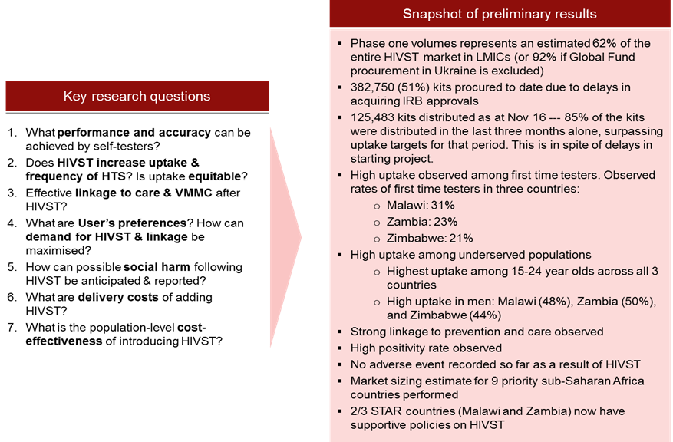
HTS: HIV testing services; IRB: institutional review board; VMMC: voluntary medical male circumcision.

Since the release of the WHO Consolidated Guidelines on HIV Testing Services in 2015, the availability of more evidence has triggered the release of a dedicated WHO HIV Self-testing and Partner Notification Guideline (launched the 1st of December, World AIDS Day). This new guideline strongly recommends HIVST as an additional approach to HIV testing services.

Country appetite for HIVST
With the release of preliminary results from the STAR project and upcoming launch of the WHO guidelines on World AIDS Day, many countries have indicated their desire to introduce HIVST as an additional tool in identifying those unreached by current models. However, given current market conditions (summarized in ‎1.1.6), country interest cannot translate into concrete country demand. Currently, only a handful of LMICs have national HIV testing policies or strategic plans that permit or support HIVST; and only a few of them have approved, registered products for HIVST. However, HIVST are increasingly sold through private pharmacies (and internet) in several countries, e.g., Namibia, Nigeria, Kenya, South Africa, etc.

HIVST product landscape
The tools used for HIVST are mainly repackaged versions of HIV professional use rapid diagnostic tests (RDT), adapted to make them more suitable for HIVST. This adaptation includes modifications to the packaging and instructions for use to make it more HIVST user-friendly.

As at November 2016, there are six HIVST RDTs (one oral fluid and five blood-based) eligible for procurement by major donors (e.g. Global Fund, UNITAID), as approved by Global Harmonization Task Force (GHTF) founding authorities. These products are described in Figure 6. However, the price of these products remains largely prohibitive for LMICs as they are mostly marketed for high-income markets. Further options for LMICs are expected in the near future.

Figure 1: Available HIV RDTs for self-testing with GHTF-regulatory approvals
Assay name (manufacturer) | Generation | Approval status | Approximate price per test (US$)
OraQuick® In-Home HIV Test  (OraSure Technologies Inc., USA) | 2nd generation | FDA; Pending CE certificate | US$ 36-40 to consumers
Autotest VIH®  (AAZ Labs, France) | 2nd generation | CE marked | US$ 25–28 to consumers
Private sector version BioSURE HIV Self Test (BioSURE, United Kingdom) | 2nd generation | CE marked | US$ 40–48 to consumers
Public sector version BioSURE HIV Self Test (BioSURE, United Kingdom) | 2nd generation | CE marked | US$ 7.50–15 to public sector
INSTI HIV Self Test  (bioLytical Laboratories, Canada) | 3rd generation | CE marked | US$ 36 to consumers

Due to market uncertainties, as well as additional packaging and modifications to the test-kit, the cost of HIVST is considerably higher than those for professional use currently available (range of $0.5 to $1.0 per test). The UNITAID/WHO assessment of the market landscape⁷ estimates that in high-income settings, HIVST can be purchased for ~US$ 7.50–48. In LMICs, current prices range from US$ 3.15 (for STAR project) to $16 per test.

In terms of the emerging pipeline, there is a rich portfolio of products on the horizon which is expected to improve competition over time. This emerging pipeline includes four finger-stick/whole blood-based and three oral fluid-based products. More established players in the professional-use RDT market (e.g. Alere), that would naturally be interested in entering into the HIVST market, have been reluctant due to current market uncertainties. To that end, immediate interventions are required to bring visibility to the market and make available products more affordable in the short-term, in anticipation of future additional price reduction through increased competition and economies of scale.

Shortcomings of HIVST market in LMICs
The HIVST market is a very nascent market that represents less than 1% of the overall HIV RDT market in LMICs, with volumes from the UNITAID STAR project account for vast majority of this HIVST market (~1 million tests/year). These low volumes make the HIVST lower-and-middle income market extremely unattractive to suppliers. Suppliers would rather focus on high-income HIVST markets and/or lower-income professional use RDT market where volumes are much larger. The unattractiveness of the market, with its limited demand, is further compounded by ambiguities surrounding forecasting, national policy and regulatory environments in several LMICs.

With very limited demand in LMICs, economies of scale cannot be leveraged to shape the market for HIVST. This current market condition perpetuates an environment where prices remain high, supplier confidence in entering market remains low, and future investments in improving product innovation remain limited.

Possible interventions in the next 24months
There is currently no established market for HIVST in LMICs. Volumes from UNITAID-funded STAR demonstration project accounts for most of total HIVST market in LMICs (<1 million tests/year, compared to the ~100million test/year professional use RDT market). Although strong country appetite to scale-up HIVST exists, the price of products remain largely unaffordable which restricts ability of countries and funders to introduce and scale-up products. Low and uncertain demand from countries in turn reinforces high prices and limited incentives to enter in the market and innovate.

In view of these challenges, there is a need to establish a market to drive down prices, stabilize the supply-base, and enable transition to countries and scale-up partners in the future. On this basis, UNITAID is proposing an AFI to create a market for HIVST by leveraging large volumes of quality-assured products and supporting early country adoption, in preparation for transition to donor and domestic funding sources.

The AFI aligns with UNITAID’s mission and the three strategic objectives of Innovation, Access, and Scalability. This area is designed to promote innovation in HIV testing; to catalyze access to emerging self-tests, and to create the conditions for scale-up to reach all people in need.

Early-adopter countries

Considerations to be taken into account include:
- Disease burden: clear and justifiable public health need for introducing HIVST (i.e. low testing coverage, coverage inequity etc.).
- Market size: aggregated demand for HIVST to have a meaningful impact on overall market.
- Country commitment and readiness for linkage actions: confirmatory testing after self-testing, enrolment in ART program for those testing positive, and linkage to prevention for those testing negative.
- Country commitment to scale-up and transition

Cost of Inaction and potential impact
The cost of inaction can be summarized by the following major market and public health effects:
- Small supplier-base of quality-assured HIVST products weakens competition, supply security and could potentially lead to shortages;
- Diminished incentives for manufacturers to engage in market, and to invest in innovation;
- Price of HIVST remains unaffordable for LMICs;
- Continued reliance on low-yield conventional testing;
- Undermined internationally agreed targets; inability to reach the first 90 target – 90% of all people living with HIV will know their HIV status – by 2020 which in turn prevents the achievement of the second and third 90 goals.
- Continued HIV transmission and advance disease progression.
The value for money of such intervention needs to be evaluated in term of public health and market impacts, as follows:

Primary Impact | Secondary Impact
- Increased number of PLHIV people identified | - Increased number of PLHIV receiving treatment (decreased treatment gap)  - Reduce mortality (improved patient outcomes)  - Reduced transmission (decrease incidence)
- Increased linkage to prevention for uninfected individuals | - Reduced transmission (decreased incidence)
- Increased opportunities for linkage (treatment or prevention) for underserved key populations | - Increased equity
- Decreased number of uninfected individuals exposed to public sector testing services, leading to increased yield of testing program | - Efficiencies and savings generated (effectiveness of the global response maximized).

Preliminary theory of change

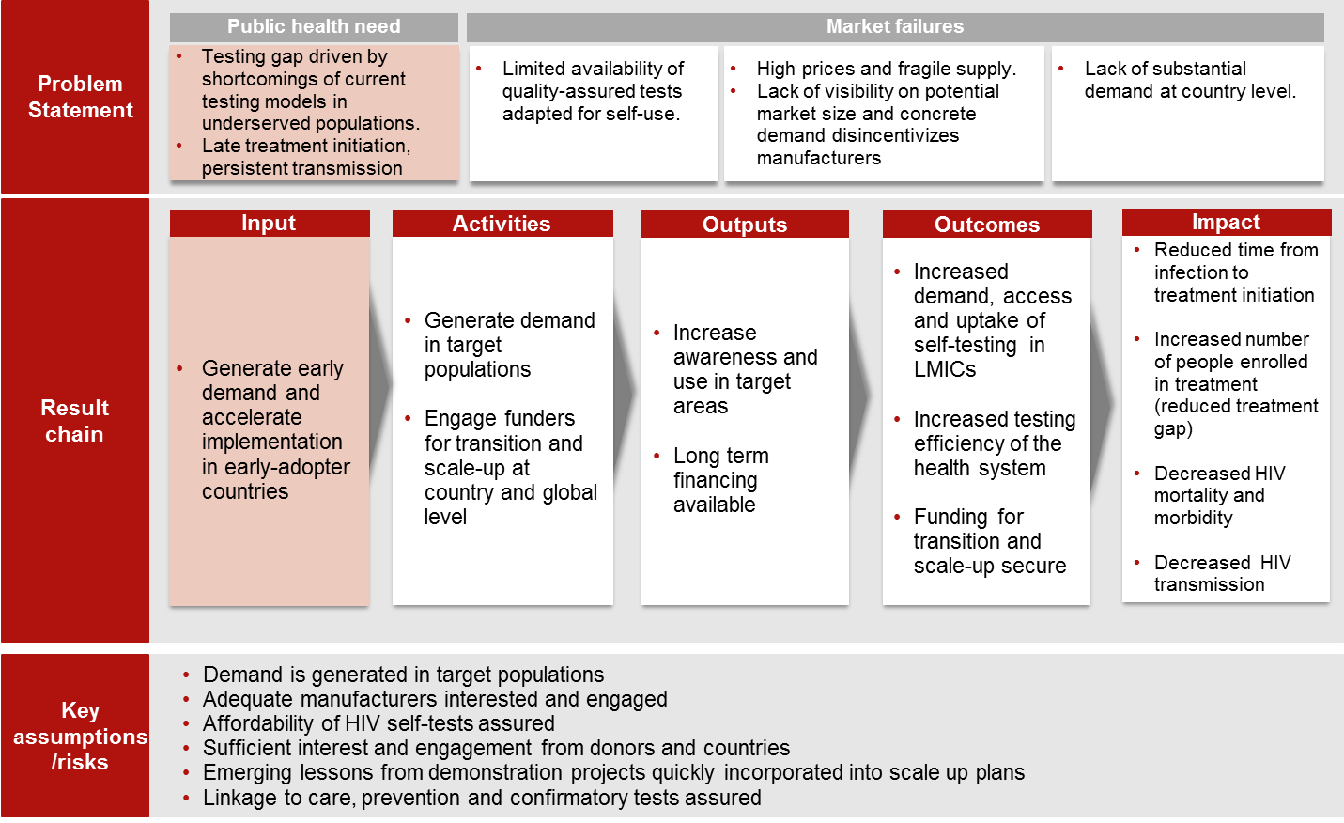

WHO (2015) Factsheet to the WHO consolidated guidelines on HIV testing services. Available from: http://apps.who.int/iris/bitstream/10665/179931/1/WHO_HIV_2015.20_eng.pdf?ua=1&ua=1
10% in 2005 to 50% in 2014
Nearly 70% of adult HIV tests reported in 76 low and middle-income countries in 2014 were among women according to the UNITAID/PSI technology landscape 2nd edition (http://unitaid.org/images/marketdynamics/publications/UNITAID_HIV_rapid_diagnostic_tests_for_self-testing.pdf)
Based on data from demographic and health survey from 2008 to 2012, less than one of every five HIV-positive girls ages 15–19 years in Africa were aware of their HIV status.
voluntary testing and counselling, provider initiated testing and counselling, community based testing, home-based testing
Venter F, Gray A. Home self-testing for HIV: AIDS exceptionalism gone wrong. SAMJ, S. Afr. Med.j. vol. 100 n.10 Cape Town October 2010.
UNITAID/WHO/BMGF/PSI HIV Rapid Diagnostic Tests for Self-Testing: Semi-Annual Update 2016 (1 December 2016)
One test has been recently reviewed by the UNITAID/Global Fund Expert Review Panel for Diagnostics (ERPD), in anticipation of WHO Prequalification or stringent approval, and is now eligible for procurement within the time restrictions and upon specific conditions and requests from programs as stipulated by ERPD process. Another ERPD call for HIVST is being prepared and additional manufacturers are expected to submit the product dossiers for review.

