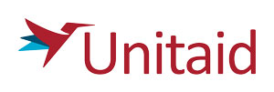
Annex 9: Anti-Terrorism Declaration

Please confirm that your entity is not and, for the duration of the Project Term, will not be involved in, or associated with, any person or entity associated with terrorism, as designated by any UN Security Council sanctions regime, that it will not make or receive any payment or provide any other support to any such person or entity and that it will not enter into any employment or subcontracting relationship with any such person or entity.

